***Lab Practical 03:***

* *Study of different network devices in detail.*

***Practical Assignment 03:***

1. *Give difference between below network devices.*

* *Hub and Switch*
* *Switch and Router*
* *Router and Gateway*

1. *Working of below network devices:*
   * *Switch*
   * *Router*
   * *Gateway*

# *Hub and Switch*

|  |  |  |
| --- | --- | --- |
| *No.* | *Hub* | *Switch* |
| *1* | *Hub is operated on Physical layer of OSI model.* | *While switch is operated on Data link layer of OSI model.* |
| *2* | *Hub is a broadcast type transmission.* | *While switch is a Unicast, multicast and broadcast type transmission.* |
| *3* | *Hub has 4/12 ports.* | *While switch can have 24 to 48 ports.* |
| *4* | *In hub, there is only one collision domain.* | *While in switch, different ports have own collision domain.* |
| *5* | *Hub is a half – duplex transmission mode.* | *While switch is a full duplex transmission mode.* |

# *Switch and Router*

|  |  |  |
| --- | --- | --- |
| *No.* | *Switch* | *Router* |
| *1* | *Switch is a data link layer device*  *i.e. layer 2.* | *Router is a network layer device*  *i.e. layer 3.* |
| *2* | *Switch works on the basis of MAC address.* | *A router works on the basis of IP address.* |
| *3* | *A Switch is a tele-communication device which receives a message from any device connected to it and then transmits the message only to the device for which the message in intended.* | *A router reads the header of incoming packet and forward it to the port for which it is intended there by determines the route. It can also perform filtering and encapsulation.* |
| *4* | *A Switch is an intelligent device as it passes on the message to the selective device by inspecting the address.* | *A route is more sophisticated and intelligent device as it can read IP address and direct the packets to another network with specified IP address. Moreover, routers, can build address tables that helps in routing decisions.* |
| *5* | *At least single network is required to connect.* | *Router needs at least two networks to connect.* |

# *Router and Gateway*

|  |  |  |
| --- | --- | --- |
| *No.* | *Router* | *Gateway* |
| *1* | *It is a hardware device which is responsible for receiving, analyzing and forwarding the data packets to other networks.* | *It is device that is used for the communication among the networks which have a different set of protocols.* |
| *2* | *It supports the dynamic routing.* | *It does not support dynamic routing.* |
| *3* | *The main function of a router is routing the traffic from one network to the other.* | *The main function of gateway is to translate one protocol to the other.* |
| *4* | *A router operates on layer 3 and layer 4 of the OSI model.* | *A gateway operates up to layer 5 of the OSI model.* |
| *5* | *Working principle of a router is to install routing details for multiple networks and routing traffic based upon the destination address.* | *Working principle of a gateway is to differentiate what is inside the network and what is outside the network.* |

# *Working of below network devices:*

1. ***Switch***
   * *When the source wants to send the data packet to the destination the packet first enters the switch and the switch reads its header and finds the MAC address of the destination to identify the device then it sends the packet out through the appropriate ports that lead to the destination devices.*
   * *Switch establishes a temporary connection between the source and destination for communication and terminates the connection once the conversation is done. Also, it offers full bandwidth to network traffic going to and from a device simultaneously to reduce collision.*

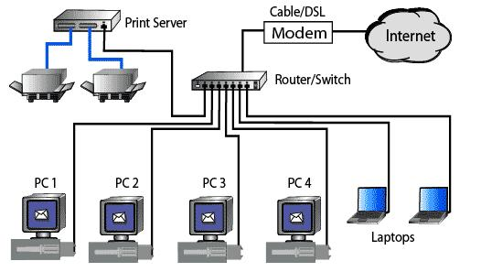

1. ***Router***
   * *Consider a router as an air traffic controller and consider data packets as planes flying to various airports (or networks)*
   * *Each packet must be directed as quickly as possible to its destination just as each plane has a distinct destination and travels a distinct route.*
   * *A router assists in guiding data packets to their intended IP address just like an air traffic controller ensures that aircraft reach their destinations without getting lost or experiencing significant disruptions in a route.*
   * *An internal routing table which is list of routes to different network destinations is used by a router to effectively direct packets.*
   * *In order to determine the destination of a packet the router first scans its header. Then, it consults the routing table. Forward packet to next packet.*

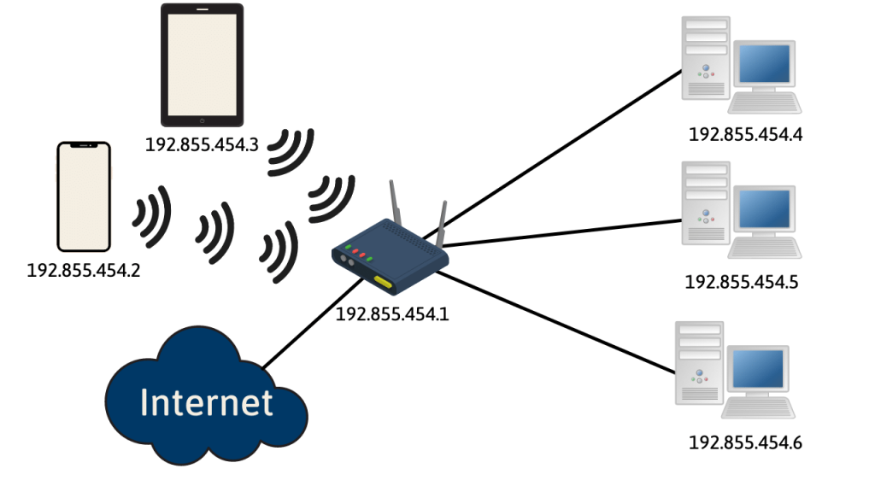

1. ***Gateway***
   * *The user end’s application made a request for a certain amount of data via its portal to the gateway. For example, A smart door made a request for the data type: “password” and send this request to the gateway.*
   * *The gateway sends this request for a password to the server.*
   * *The server receives the request and search for the data type: “password” for a certain “id” and made the data “password” transfer to the gateway.*
   * *The data is then sent to the smart door interface where its matched with the data entered for data type: “password”. If these two data matches then the door gets unlocked.*

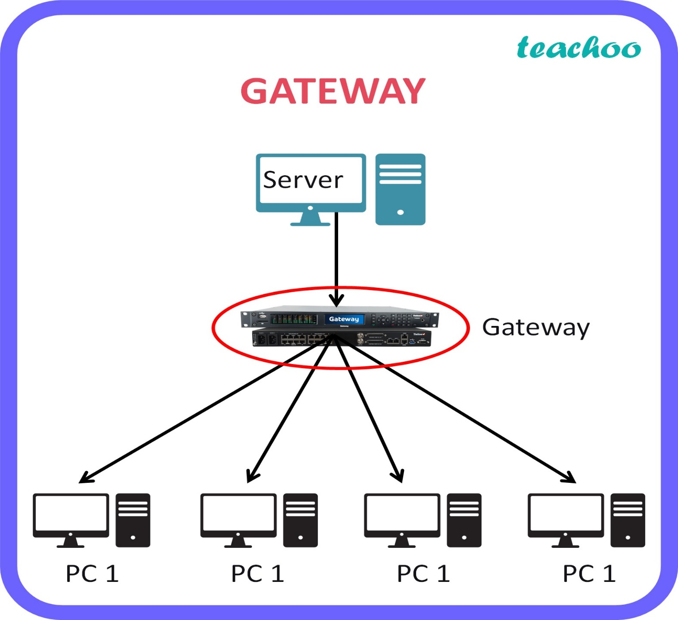

**PC-1 PC-2 PC-3 PC-4**